

Bachelor of Computer Applications (BCA) Programme

Seminar Report

BCA Sem VI

AY 2022-23

**Iris scanner**

*By*

|  |  |
| --- | --- |
| Exam No | Name of Student |
| 3384 | Devani Drashti G. |
|  | |

|  |  |
| --- | --- |
| Seminar Guide by : | |
| **Prof. Khushbu Surati** |  |



C E R T I F I C A T E

This is to certify that

Ms. Devani Drashti Ghanshyambhai examination number 3384 has satisfactorily completed her seminar work entitled IRIS Scanner as partial fulfillment of requirements for BCA Sem VI, during the academic year 2022-23.

|  |  |
| --- | --- |
| Date: 26/04/2023 |  |
| Place: Surat | Prof. KhushbuSurati  SDJ International College,  Surat |

**Acknowledgement**

The success and final outcome of this seminar required a lot of guidance and assistance from many people and we are extremely fortunate to have got this all along the completion of my seminar work. Whatever I have done is only due to such guidance and assistance.

I would not forget to thank I/C Principal Dr. Aditi Bhatt, Head of Department Dr. Vaibhav Desai and Project guide Prof. Khushbu Suarti, and all other Assistant professors of SDJ International College, who took keen interest on our seminar work and guided us all along, till the completion of my seminar work by providing all the necessary information for developing a good system.

I am extremely grateful to her for providing such a nice support and guidance though she had busy schedule managing the college dealings.

I am thankful and fortunate enough to get support and guidance from all Teaching staffs of Bachelor of Computer Application Department which helped us in successfully completing my seminar work. Also, we would like to extend our sincere regards to all the non-teaching staff of Bachelor of Computer Application Department for their timely support.

Devani Drashti (3384)

*I N D E X*

|  |  |  |
| --- | --- | --- |
| **Sr. No** | **Description** | **Page No.** |
| 1 | overview | 5 |
| 2 | Introduction | 7 |
| 3 | History | 12 |
| 4 | Structure and working | 14 |
| 5 | Iris recognition in  television and movies | 19 |
| 6 | Iris applications | 21 |
| 7 | Advantages of iris scanner | 27 |
| 8 | Disadvantages of iris scanner | 29 |
| 9 | Future scope | 30 |
| 10 | Conclusion | 31 |
| 11 | References | 32 |

**1. Overview of Topic**

A iris scanner is a type of technology that identifies and authenticates the iris of an individual

in order to grant or deny access to a computer system or a physical facility.

It is a type of biometric security technology that utilise the combinations of hardware and software techniques to identify the iris scans of an individual.

A iris can a typically works by first recording eye scans of all authorized individual for a particular System or facility. These scans are saved within a database. the user requiring access their on a software scanner which scans and copies the input from the individual and looks for any same Within the already stored scans. If there is a positive match. The individual is a granted access.

Iris scanners are security systems of biometrics. They are used to unlock doors and in other

security application. during the 2015s iris scanners become commonplace on mobile phone.

People have a different colour pattern on their eyes. This eye cannot be removed or changed.

Every eyes are different from any other in world.

After covid, this technology ratio had grown rapidly. Before this problem, every individual had

preferred to used as fingerprint scanner . However, during this present period everywhere iris

scanners are Utilized .For instance bank, mobile and door.

Now days, There is no doubts iris scanning technology use as faster .therefore, iris advancement more and more grow as compared to past era.

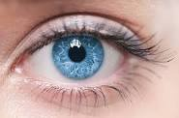

**Figure 1.1. green eyes**

**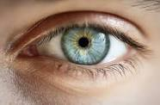**

**Figure 1.2. blue eyes**

**2.** **Introduction**

**2.1 basic introduction :**

Iris recognition or iris scanning is the process of using visible and near-infrared light to take a high contrast photograph of a person’s iris.It is a form of biometric technology in the same category as face recognition and fingerprinting.

Iris recognition is not a new idea but has only been available in practical application for the last 10 to 15 years. This idea has been featured in many science fiction movies but until recently was just a the oretical concept. Iris recognition is used for security purposes and is an almost fool pro of entry-level access security means because of its ability to readily identify false irises . It has not been widely used because of the cost, but has applications that are ever increasing.

Advocates of iris scanning technology claim it allows law enforcement officers to compare iris images of suspects with an existing database of images in order to determine or confirm the subject identity.They also state that iris scans are quicker and more reliable than fingerprint scans since it iseasier for an individual to obscure or alter their fingers than it is to alter their eyes.

Iris scanning raises significant civil liberties and privacy concerns.It may be possible to scan irisfrom a distance or even on the move, which means that data could be collected surreptitiously, without individuals’ knowledge, let alone consent. There are security concerns as well: if a database of biometric information is stolen or compromised, it is not possible to get a new set of eyes like one would get a reissued credit card number. And iris biometrics are often collected and stored by third-party vendors, which greatly expands this security problem.

Iris recognition emerges as one of the most useful modalities for biometrics recognition in last

Few decades. The goal of iris recognition is to recognize human identity through the textural

characteristics of one’s iris muscular patterns.

The procedures for iris recognition usually consist of four stages: image acquisition,irissegmentation feature extraction, and pattern matching.

The iris recognition has been acknowledged as one of the most accurate biometric modalities

because of its high recognition rate. It has been applied in the field of border control and national security. More and more countries and private companies have shown interests to use the technique of iris recognition.

**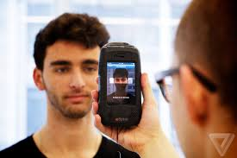 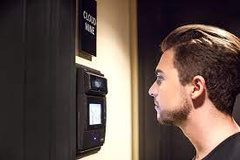**

**Figure 2.1 iris mobile scanner Figure 2.2 iris machine scanner**

Iris recognition is a biometric that depends on the uniqueness of the iris. The iris is a unique organ that is composed of pigmented vessels and ligaments forming unique linear marks, slight ridges, grooves, furrows, vasculature , and other similar features and marks . Comparing more features of the iris increases the likelihood of uniqueness. Since more features are being measured, it is less probable for two irises to match. Another benefit of using the iris is its stability. The iris remains stable for a lifetime because it is not subjected to the environment, as it is protected by the cornea and aqueous humor.

The process of iris recognition is complex. It begins by scanning a person’s iris Henahan, 2002.The individual stares into a camera for at least a second allowing the camera to scan their iris. An algorithm Iris Recognition: A General Overview 19 processes the digital image created by the camera to locate the iris. Once the iris has been located, another algorithm encodes the iris into a phase code that is the 2048-bit binary representation of an iris Daugman. The phase code is then compared with a database of phase codes looking for a match. On a 300 MHz Sun Microsystems processor more than 100,000 iris codes can be compared in a second . In a matter of a few seconds an individual can have his/her eyes scanned and matched to an iris code in a database identifying the individual.

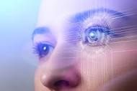

**Figure 2.3 eye scanning**

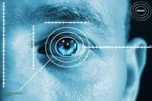

**Figure 2.4 iris scanner**

**2.2 Biometric :**

A biometric system is essentially a pattern recognition system which makes a personalidentiﬁcation by determining the authenticity of a speciﬁc physiological or behavioral char-acteristic possessed by the user.

Biometric technology is a technology that uses the measurements of a unique human at-tribute or feature in order to distinguish that person from all others. Characteristics fall into two categories:

• Physiological are related to the shape of the body. Examples are facial recognition - 2D,3D,Thermographic ; Retinal scanning ; Iris scanning ; Finger Scanning - ﬁngertip, thumb,length, pattem ; Palm Scanning - print, topography ; Hand Geometry ; Wrist/Hand Vein ; EarShape etc.

• Behavioural are related to the behavior of a person. Examples are Voice Prints; DynamicSignature Veriﬁcation ; Keystroke Dynamics etc.Behavioural biometric systems tend to be less expensive than physical biometric systems butalso less robust. Behavioural characteristics can be drawn ﬁom the dynamic attributes of theuser, however these features may not necessarily be unique to one individual.

Biometric technologies generally refer to the use of technology to identify aperson based on some aspect of their biology. Fingerprint recognition is one of the ﬁrst andoriginal biometric technologies that have been grouped loosely under digital forensics.

**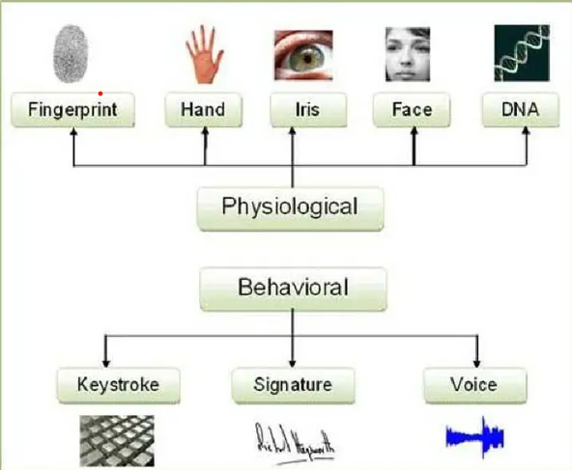**

**Figure 2.5. biometric**

**3. History**

The history of iris recognition is relatively young. It all began in 1936 when ophthalmologist

Frank Burch identified differences between human irises and proposed the patterns as a method to recognize individuals.However, it was not until 1987 when doctors, Leonard Flam and Aran Safir, were awarded a patent for the iris identification concept, based on the idea that no two irises are the same. The upswing of iris recognition as an identification method came

just after the millennium when patents expired and the technology was ready for broad commercialization.

The first general concept patent addressing iris recognition can be attributed to the work of Drs. Leonard Flom and Aron Safir in the 1980s. However, iris recognition’s utility as a human authentication method would have remained little more than a notion had it not been for John Daugman and provide the ability to match one iris against another found via exhaustive search of even very large databases. Unquestionably the world’s leading authority on iris recognition, a wealth of scientific and technical information about iris recognition can be gleaned from Dr. Daugman’s website  at the UK’s University of Cambridge.

In a world challenged to find new ways to authenticate identity and privileges while processing people, information and delivering increased levels of security, the future of iris recognition technology looks bright. Iris ID’s commitment to remain a leader in the field is strong. Given the company’ s core competence in security, IT product design and development, wireless and a host of other areas that lend themselves to application development, the fit and prospects iris recognition technology affords Iris ID for growth are promising.



**Figure 3.1 father of Iris scanner**

**4. Structure and Working**

**4.1 Why iris ?**

Accurate and Reliable: More accurate than other security alternatives biometric or otherwise. Adistinctive pattern is not susceptible to theft, loss or compromise. Fast and Stable:Unique iris pattern is formed by 10 months of age, and remains stable throughout one’s life.Full enrollment with instruction can take less than 2 minutes. Authentication takes less than 2seconds. Expandable, Scalable, and Flexible: Data templates require only 512 bytes of storageper iris and even very large databases do not compromise search speed or degrade performanceaccuracy. Operates in standalone mode and easily integrates into existing security systems.

**4.2 What is Iris ?**

iris is the area of where the pigmented or colored circle,usually brown,blue,rings the dark pupil

of the eye.

**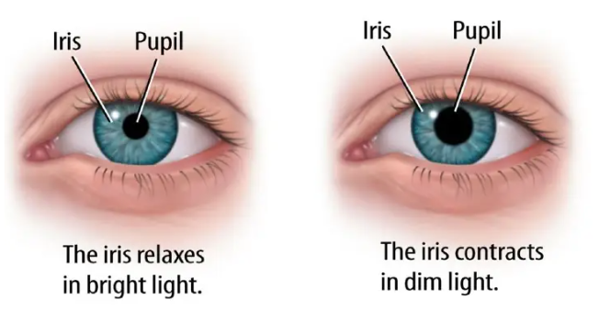**

**Figure 4.1. Iris detection**

Iris recognition is an automated method of biometric identiﬁcation that uses mathematical

pattern-recognition techniques on video images of one or both of the irises of an individual’seyes, whose complex patterns are unique, stable, and can be seen from some distance.

Iris scanning measures the unique patterns in irises, the colored circles in people’s eyes. Biometric iris recognition scanners work by illuminating the iris with invisible infrared light to pick up unique patterns that are not visible to the naked eye. Iris scanners detect and exclude eyelashes, eyelids, and specular reflections that typically block parts of the iris. The final result is a set of pixels containing only the iris. Next, the pattern of the eye’s lines and colors are analyzed to extract a bit pattern that encodes the information in the iris. This bit pattern is digitized and compared to stored templates in a database for verification (one-to-one template matching) or identification (one-to-many template matching).

Iris scanners collect around 240 biometric features, the amalgamation of which are unique

every eye. The scanners then create a digital representation of that data. That numeric representation of information extracted from the iris image is stored in a computer database.

## GalaxyNote7_Feature_Iris_Main_Final_4.jpg

## Figure 4.2. Iris scanner system

## 4.3 Iris scanning process :

There are four main steps involved in iris scanner :

### 1. Image capture

A high-quality image of the individual’s left and right iris must be captured using a specialized iris camera. These cameras use near-infrared (NIR) sensors to capture the minute and intricate details of the iris with much greater accuracy than visible light (VIS), which can pollute the sample. Research from Michigan State has determined that iris recognition accuracy drops significantly when VIS is used instead of NIR. Visible light is also more at risk of causing discomfort and pupil contraction when shined into a subject’s eyes. By comparison, near IR causes neither pupil contraction nor discomfort during an iris scan.

### 2. Compliance check and image enhancement

The next step is to perform quality and compliance checks to ensure that the captured image is suitable as a biometric template for future iris scanning. This requires specialized software that analyzes each image for key characteristics that indicate quality, including, but not limited to:

* Sharpness.
* Gray-level spread.
* Margin.
* Iris sclera contrast.
* Iris pupil contrast and pupillary dilation.
* Eyelash presence.
* Eyelid occlusion.

Once the iris has been segmented from the rest of the eye and evaluated for quality, the sample can be saved for future use as a biometric template.

### 3. Image compression

Each iris-scan template should be compressed using the JPEG 2000 format. This format preserves image quality and minimizes the occurrence of artifacts that result from other compression methods.

### 4. Biometric template creation for matching

Finally, the high-quality sample is put to use as a template for iris scanning.In one-to-one authentication, each live scan of an individual’s iris is compared to the existing template for identification and authentication. In one-to-many authentication, a live scan is analyzed and compared against an existing gallery to identify a match or lack thereof.

**5. Iris recognition in television and movies**

In year 2014 , a Hollywood film by writer-director Mike Cahill and winner of the Alfred Sloan Award for best exposition of technology (2014 Sundance Film Festival), uses iris recognition for its core plot.Culminating in India with the UIDAI project to encode and enroll the iris patterns of one billion or more Indian residents by the end of 2015, the film is described as a *"*science fiction love story *"*, seeking to reconcile science with religious spirit-world beliefs.

Steven Spielberg's 2002 science fiction film Minority Report depicts a society in which what appears to be a form of iris recognition has become daily practice. The principal character undergoes an eye transplant in order to change his identity but continues to use his original eyes to gain access to restricted locations.

In The Island (2005), a clone character played by Ewan McGregor uses his eye to gain access through a security door in the home of his DNA donor.

The Simpsons Movie (2007) features a scene that illustrates the difficulty of image acquisition in iris recognition.

The TV series Numb3rs *,* features a scene where a robber gets into the CalSci facility by cracking the code assigned to a specific iris.

The 2010 film Red includes a scene where Bruce Willis' character uses a contact lens to pass an iris scan and gain access to CIA headquarters.

The film "Angels and Demons" and also the book featured an iris scanner as the method by which the protagonist broke into CERN and stole one of the antimatter storage modules.

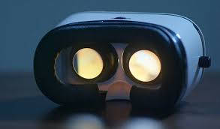

**Figure 5.1. Iris scanner headset**

**6. Iris applications**

Iris recognition technology is being used in banks and financial organizations , replacing the cumbersome and time taking, pin based, and password based systems.

The use of iris recognition is expected to improve standards of financial services as the bankers will become free from time consuming document processing for identity proofs. This in turn will give them ample time and opportunity to concentrate on other important areas such as customer service.

* **national border controls: the iris as a living passport**

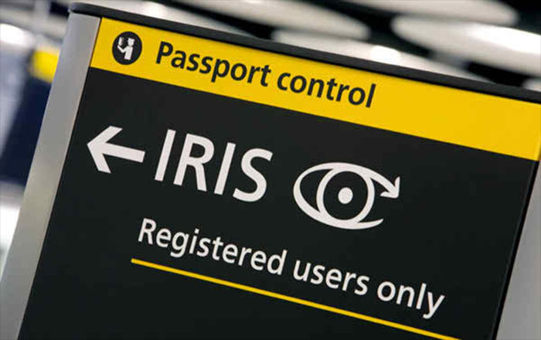

**Figure 6.1 living passport**

* **computer login: the iris as a living password**

**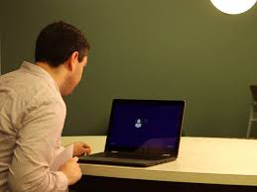**

**Figure 6.2 computer password**

* **cell phone and other wireless-device-based authentication**

**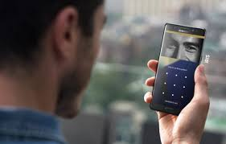**

**Figure 6.3 cellphone**

* **secure access to bank accounts at cash machines**

**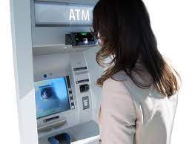**

**Figure 6.4 cash machine**

* **ticketless travel, authentication of rights to services**

**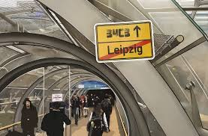**

**Figure 6.5 ticketless iris system**

* **premises access control (home, office, laboratory, etc)**

**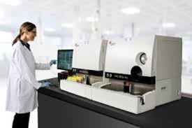**

**Figure 6.6 laboratory iris system**

* **driving licenses , other personal certificates**

****

**Figure 6.7 personal certificate**

* **entitlements and benefits authorization**

**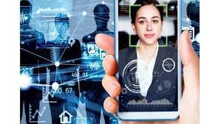**

**Figure 6.8 authorization**

* **forensics, birth certificates, tracing missing or wanted persons**

**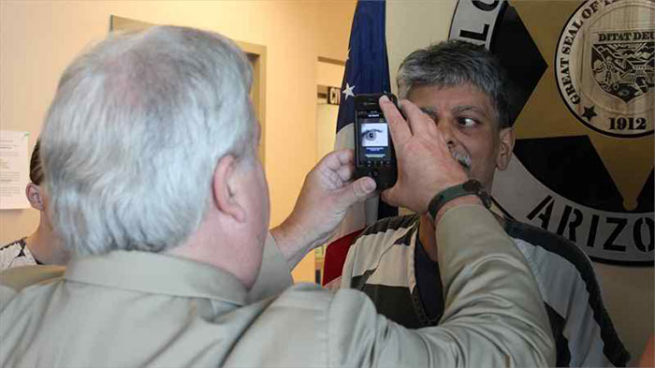**

**Figure 6.9 tracing missing**

* **credit-card authentication**

****

**Figure 6.10 credit card**

* **automobile ignition and unlocking; anti-theft devices**

**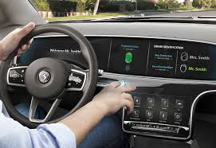**

**Figure 6.11 automobile**

* **anti-terrorism ( security screening at airports)**

****

**Figure 6.12 anti terrorism**

* **secure financial transactions (electronic commerce, banking)**

**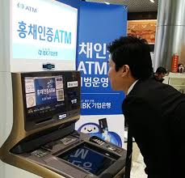**

**Figure 6.13 secure online transaction**

* **Internet security, control of access to privileged information**

****

**Figure 6.14 internet security**

* **Biometric-Key Cryptography (stable keys from unstable templates)**

**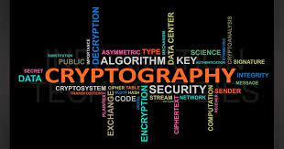**

**Figure 6.15 cryptographyin iris system**

* **any existing use of keys, cards, PINs, or passwords**

**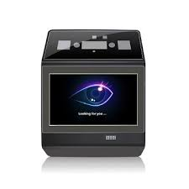**

**Figure 6.16 password in iris system**

**7. Advantage of iris scanner**

## 1 . Accuracy :

The iris authentication matches the complex mathematical patterns of the irises which are significantly unique for each. A comprehensive study on biometric authentication found that the false rejection rate of iris authentication is only 1.8% which is the lowest.

## 2. Scalability :

Iris biometric authentication is highly scalable for any size of a project. The technology has been deployed in many government projects like National ID or immigration as well as in healthcare services.

## 3.Hygiene :

Iris can be scanned from a distance which ensures hygiene factor, unlike fingerprint or retina. It’s like to take a picture and doesn’t require any contact with the scanner.

## 4. Stable :

The mathematical patterns of iris remain same throughout the life of the individual which is which is the unique feature of this modalities and protected by the natural biological process of the body.

## 

## 5. Highly Secured :

The iris is extremely difficult to be forged for its uniqueness of the patterns. As a result, it assures the highest level of security and become the most reliable biometric authentication system.

## 6. Randomness :

Iris patterns have the high degree of randomness which allows the variability by 244 degrees-of-freedom And entropy by 3.2 bits per square millimeter. In both cases , the uniqueness is set by combinatorial complexity. So, the identification remains faster and safer.

## 7. Tractable :

Decision making and encoding are tractable in iris authentication because the image analysis

and encoding time of the scanner are only 30 milliseconds, the decidability index is typically

6 to 8.

## 8. Faster Matching :

If the individual is already enrolled in the biometric system, then the iris biometric authentication could be the quicker way of authentication than the others because of its higher degrees-of-freedom and faster encoding time.

## 9. Easy to use :

A person needs to stand still in front of the camera, and the job is done instantly. It is a comfortable processfor everyone which doesn’t require any special skills and environment to use it.

**8. Disadvantage of iris scanner**

**1. Distance :**

whilst we have discussed the merits of contactless technology, there is still a maximum distance a person can stand from an iris scanner which may be challenging in certain environments.

**2. Movement** :

To accurately scan the iris, the technology relies on the subject remaining as still as possible. If a handheld scanner is being used, it also relies on the operator having a steady hand, otherwise, iris scanning may be tricky.

**3. Memory** :

computer memory is required for the data storage; however, this is becoming less of an issue as we move towards cloud-based storage solutions.

**4. Reflection** :

placement of the scanner is important to the elimination of reflections due to contact lenses and eyeglasses.

**5. Cost** :

due to their high levels of accuracy, iris scanners may be more expensive than other forms of biometric hardware. Fingerprint Recognition and Facial Recognition may represent provide more cost-effective solutions in some circumstances.

**9. Future scope**

To make the study more useful and effective the following suggestion have been proposed for further improvements in this area.

To develop improved algorithms and data capturing sensors to reduce the level of failureto enrol and failure to acquire rate.

To concern segmenting noisy irises when the lower or upper eyelids and eyelashes coverthe pupil of the iris, which is currently not handled.

To work on optimization of the code, so that the segmentation software can run in realtime applications.

To study additional type of noises like off-angle iris images may be more useful. A lowquality and degraded eye images have been considered here.

To concern to security analysis of the proposed hybrid mechanism on noisy irises whenthe lower or upper eyelids and eyelashes cover the pupil of the iris.

**10. Conclusion**

Iris recognition has proven to be a very useful and versatile security measure. It is a quick and accurate way of identifying an individual with no room for human error.Iris recognition is widely used in the transportatio industry and can have many applications in other ields where security is necessary. Its use has been successful with little to no exception, and iris recognition will prove to be a widely used security measure in the future.

This method of identification depends on relatively unchangeable features and thus it is

more accurately defined as authentication. We conclude that implementation of Half Polar Iris Localization improves accuracy of detection.

The Iris Dataset contains four features of 50 samples of three species of Iris . These measures

were used to create a linear discriminant model to classify the species.

The extracted addition features should be able to over-come the problem of real time implementation of the process. Unsupervised classiﬁers can beused to develop the process further.

Biometric iris recognition systems are easy to use and create a free security environment. Iris scanners can be used to protect high value locations by denying access to unwarranted visitors. Business and governmental organizations across the board have recognized the benefits of this system and have gone about implementing iris recognition based authentication systems in a big way.

**11. References**

* <https://en.wikipedia.org/wiki/Iris_recognition>
* <https://www.eff.org/pages/iris-recognition>
* <https://www.innovatrics.com/iris-recognition-technology/>
* <https://recfaces.com/articles/iris-scanner>
* <https://www.aware.com/iris-recognition/>
* <https://www.youtube.com/>